## Checklist DST – Berkeley 2018 – no amblyopia

#### INITIALIZATION - PREPARATION (prior to participant’s arrival)

1. Computer login: admin / no password
2. Stereoscope
   1. The chinrest should be 1.5m from the monitor.
   2. Make sure no part of the stereoscope is missing (fig. A).
   3. Adjust the position of the stereoscope so that it is facing the monitor and lock the wheels by putting the switch up.
   4. Open the black screens to the max position (indicated)

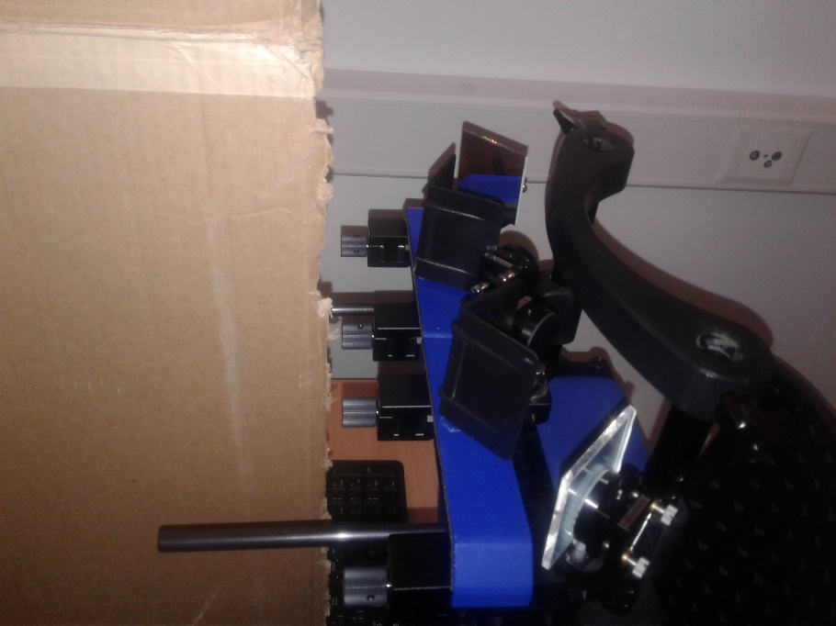

**fig. A – stereoscope**

#### PARTICIPANT INSTRUCTIONS

1. Chair and chinrest position
   1. Be sure the participant has correct prescriptions (glasses).
   2. Launch runDST8
      1. Enter the name for saving file (participant code).
   3. Check that their eyelevel intersects the center of the small mirrors or adjust chinrest height to get this result.
2. Mirror calibration
   1. Cover the left eye’s mirrors and ask the participant to move the big box with the appropriate mirror knob (fig. B – knob) so that the green line is aligned with the green stick when looking at the stick above the mirrors.

*« Can you see the green bar above the mirror, not the one through the mirrors? Can you align that green bar above the mirrors with the green line that you see through the mirrors? “*

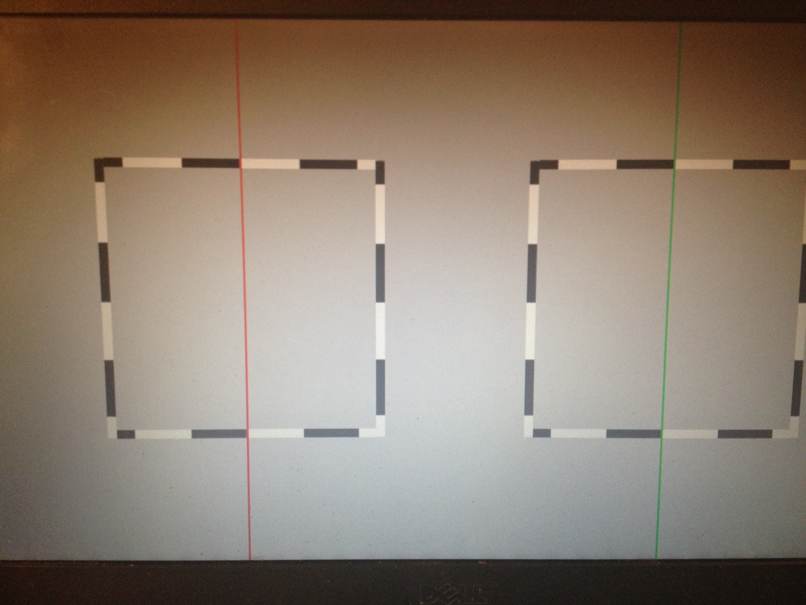

* 1. Put your finger on the screen on the left edge of the left big box and check if it is visible. Then do the same with right edge. Repeat with the other eye.

*“Can you see my finger here?”*

* + 1. If the box in the non-occluded eye is not fully visible, instruct the participant to make it visible using the knob and retry the previous step.

1. Task 1: Screen calibration
   1. Press space and give the keyboard to the participant.
   2. Ask the participant to move the two parts of the fixation circle together so that they match vertically, using arrow keys [↑ ↓].

*“Please use the up and down arrows on keyboard to align the center of the two half circles vertically. It is not important if the half-circles do not assemble into a full circle.”*

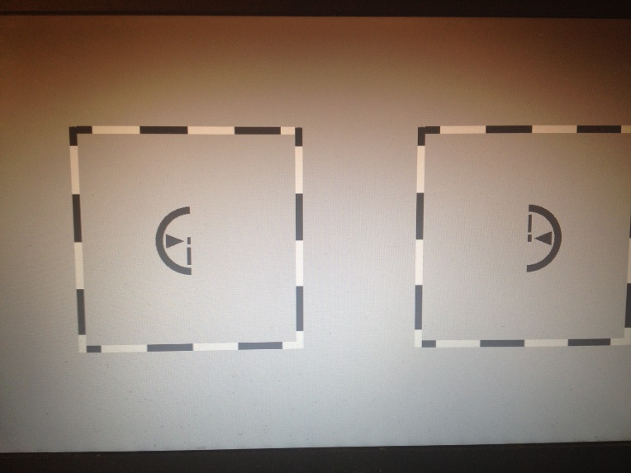

* 1. Check that the big box is seen as one.

*“Do you see one or two boxes?”*

1. Task 2: Diplopia test
   1. After instructions panel, ask to press any key.

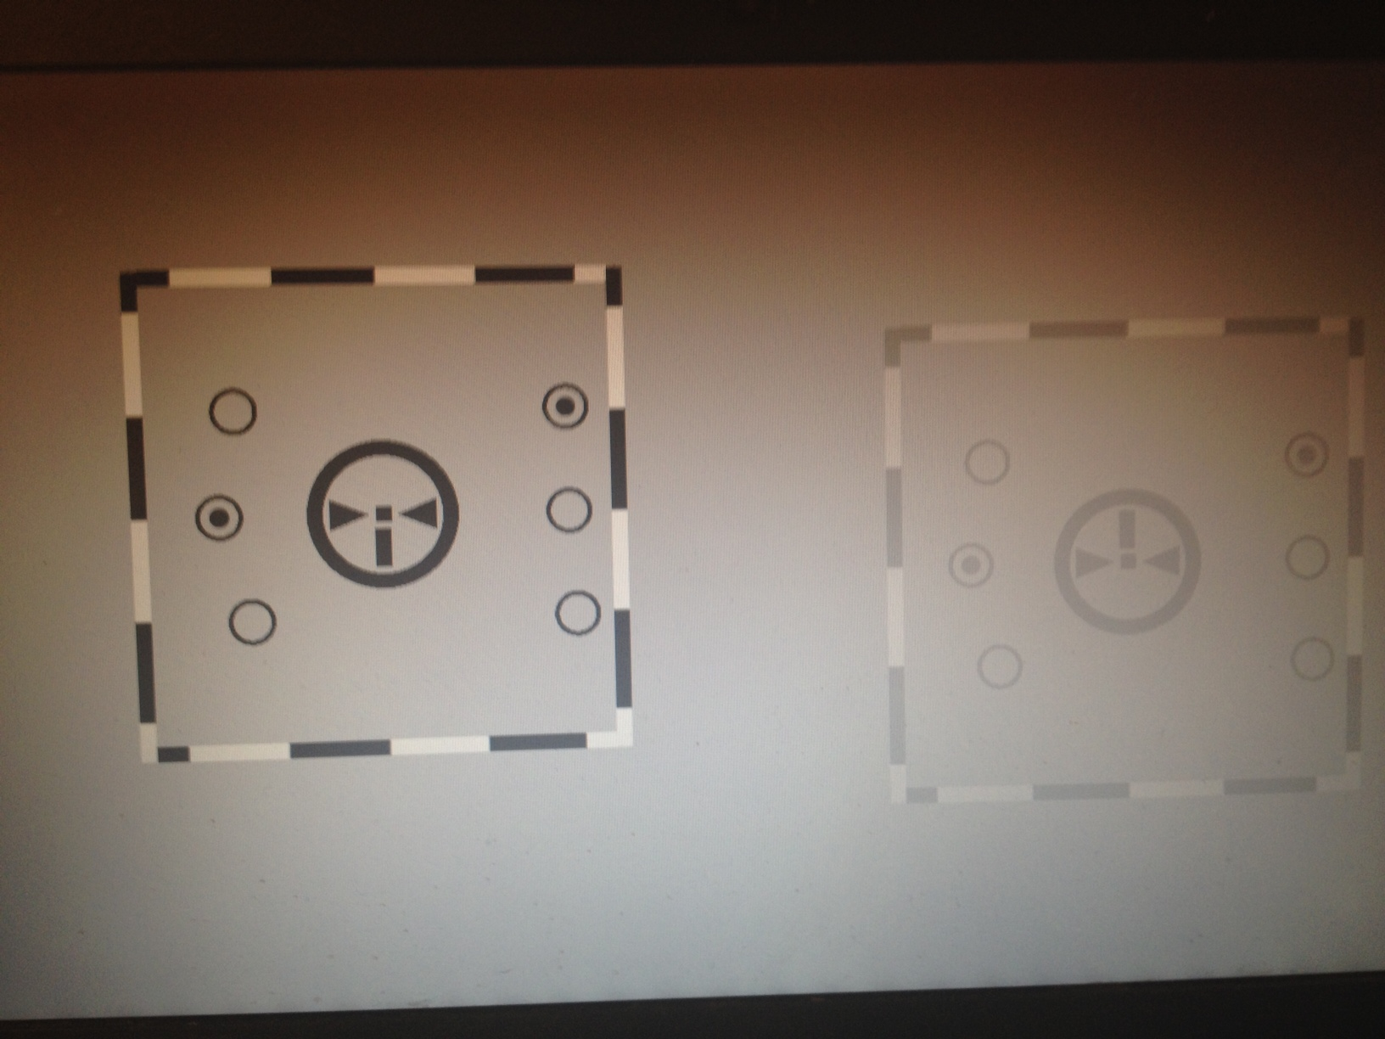

* 1. Ask the participants if he can see the 6 circles. If he reports more circles than 6, move back to Mirror calibration by pressing space.

*“In the center of the large box, you should see a large circle and small circles around, some with a dot inside. How many small circles do you see?”*

* 1. Ask the participant to report the total number of dots he can see, while he is always fixating, with the keys on the pad, between 0 (with the thumb) and 4, 4 actually being numpad enter (that way, all the fingers are aligned).

*“I show you how to put your hand on the numbers to report answers. Your task is to count the number of dots inside the small circles. If you see only one dot but one time with the left eye, and one time with the right eye, like in double vision, report two dots.”*

1. Task 3: Suppression test
   1. After instructions panel, ask to press any key.
   2. Tell the participant that the task is the same, except that now, there is either 1 or no dot visible.

*“This is the same as before, except that you will be presented either one dot or not dot, so use the 0 and 1 keys”*

* 1. At any time, if the participant lose fusion and need to change the mirror calibration, you can abort and go back to mirror calibration step by pressing space bar.

#### RESULTS

If diplopia score is >20% or if suppression is <1 for one eye, run the DST again with different settings (follow DST amblyopia scenario Chart).